Analysis of GDP Percentage Spent on Premature Deaths Resulting from Ambient Air Pollution and Unsafe Water Supply Among 37 Countries

**Introduction**

As of the 21st Century, countries are rapidly expanding and developing, leading to increased pollution around the world. Increased pollution among changing water quality leads to poorer health among many, ultimately altering the death rates internationally. Specifically, for this analysis, death rates will be represented by the total GDP cost spent on welfare among various countries. The null hypothesis is that the death rate (modeled by the total percentage of GDP spent on premature death rates) will be statistically higher for death caused by ambient air pollution than those caused by obtaining water from unsafe sources. Justification for this comes from the fact that previously developing countries are beginning to industrialize, leading to an increase in air pollution and likely a decrease in unsafe water sources. An alternate hypothesis is that the average death rate caused by unsafe water is greater than that caused by air pollution. Using common notation, let $μ_{a}$ denote the average death rate caused by ambient air pollution and similarly $μ_{w}$ denote the average death rate caused by individuals obtaining water from unsafe sources. The null hypothesis and alternate hypothesis are stated respectively as follows:

$$H_{0}:μ_{a}>μ_{w}$$

$$H_{a}:μ_{a}<μ_{w}$$

To investigate this hypothesis, data was gathered from the website for the Organization for Economic Co-Operation and Development (<https://stats.oecd.org/>) from the data table titled “Mortality, Morbidity, and Welfare Cost from Exposure to Environment-Related Risks.” All data collected was from the year 2017 to ensure results were recent without including any abnormalities which may have occurred over the last three years. One limitation of this study is that only the first 38 countries were analyzed, as there were discrepancies among how to handle the OECD categorization of multiple countries into single regions which were tabulated on their data (for example, OECD reported data for both the European Union and Euro Area). This limitation is not detrimental to this investigation as the 38 countries analyzed are distributed among the major global regions (North America, South America, Europe, Asia, and Africa) and this sample size exceeds the minimum criteria by 8 nations.

**Graphs and Descriptive Statistics**

It is important to begin by remarking that this investigation was completed by analyzing two independent samples, and so this inquiry will consist of a two-sample t-test. That is, both samples will be analyzed separately and not together. Firstly, by examining the bar plots generated for both air pollution and unsafe water, it is easily observed that, generally speaking, air pollution is cause for a higher death rate than unsafe water.

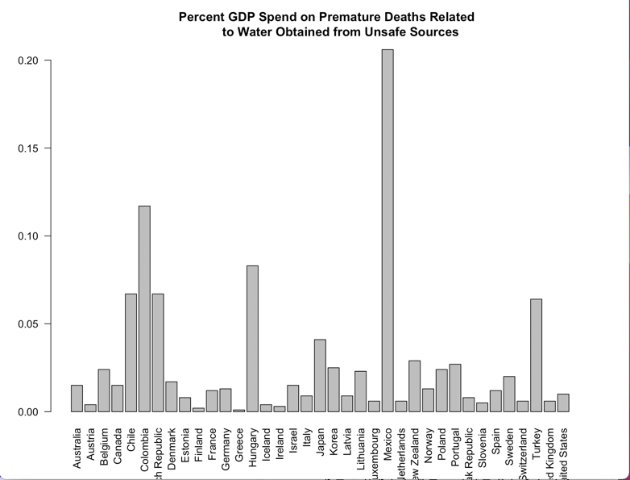

Additionally, comparing the boxplots between death rates related to air pollution and unsafe water